第五次上机实验报告

**学号**：202030310170 **姓名**：程子健 **班级**：电自2001

**程序代码**

#include<iostream>

using namespace std;

class Base {

public:

void setx(int i)

{

x = i;

}

int getx()

{

return x;

}

public:

int x;

};

class Derived :public Base {

public:

void sety(int i)

{

y = i;

}

int gety()

{

return y;

}

void show()

{

cout << "Base::x=" << x << endl;

}

public:

int y;

};

int main()

{

Derived bb;

bb.setx(16);

bb.sety(25);

bb.show();

cout << "Base::x=" << bb.x << endl;

cout << "Derived::y=" << bb.y << endl;

cout << "Base::x=" << bb.getx() << endl;

cout << "Derived::y=" << bb.gety() << endl;

return 0;

}

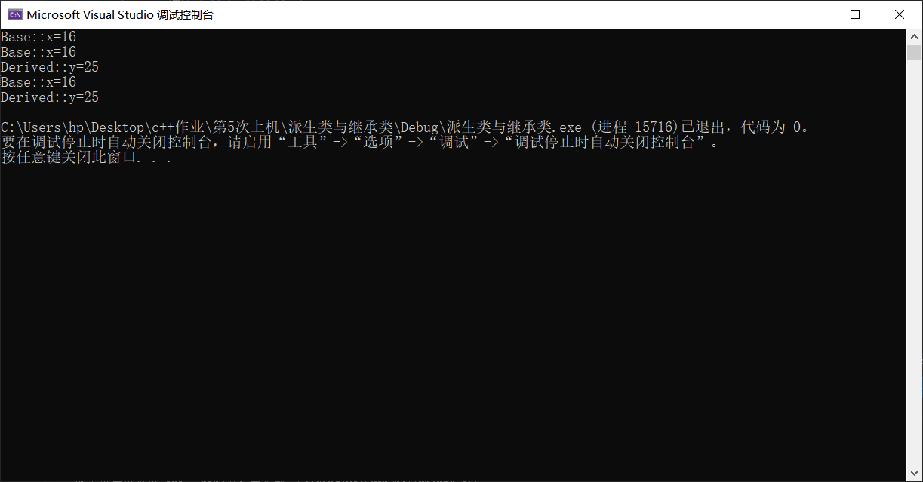

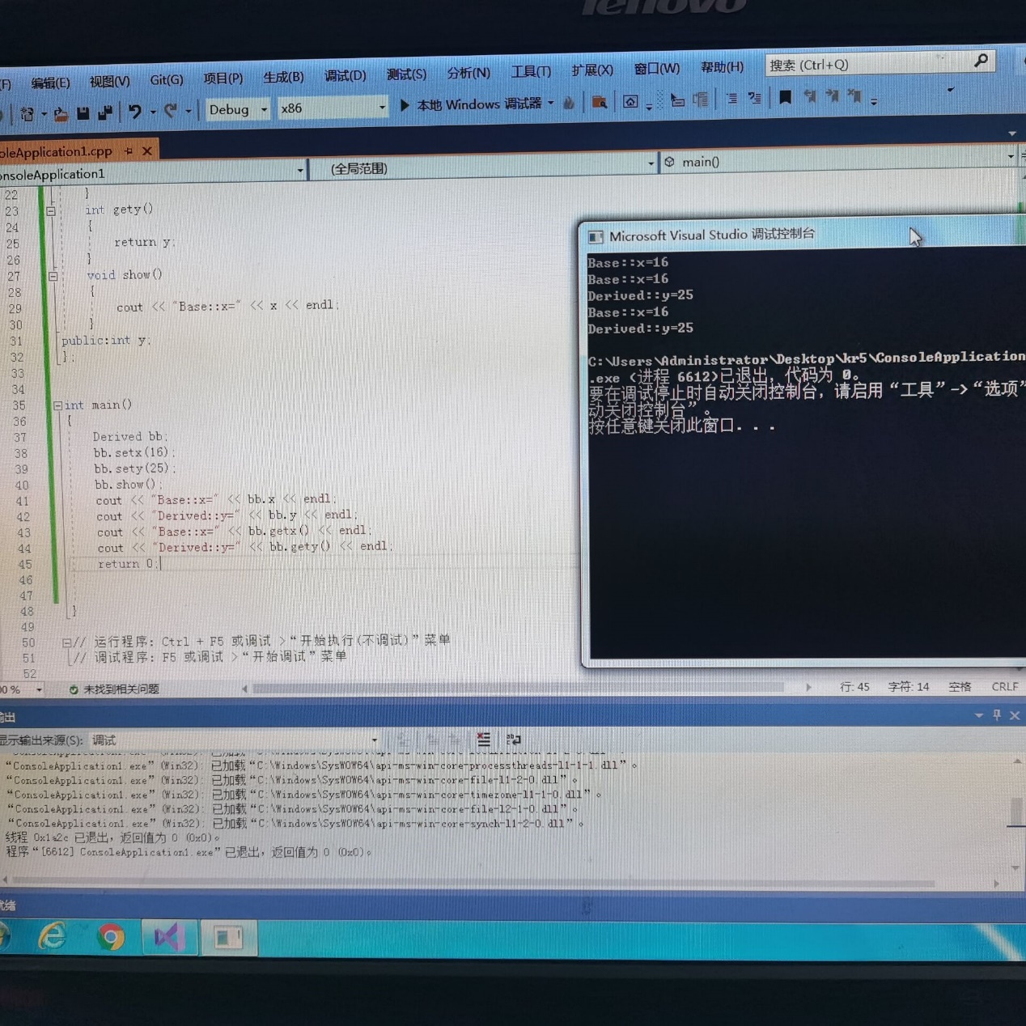

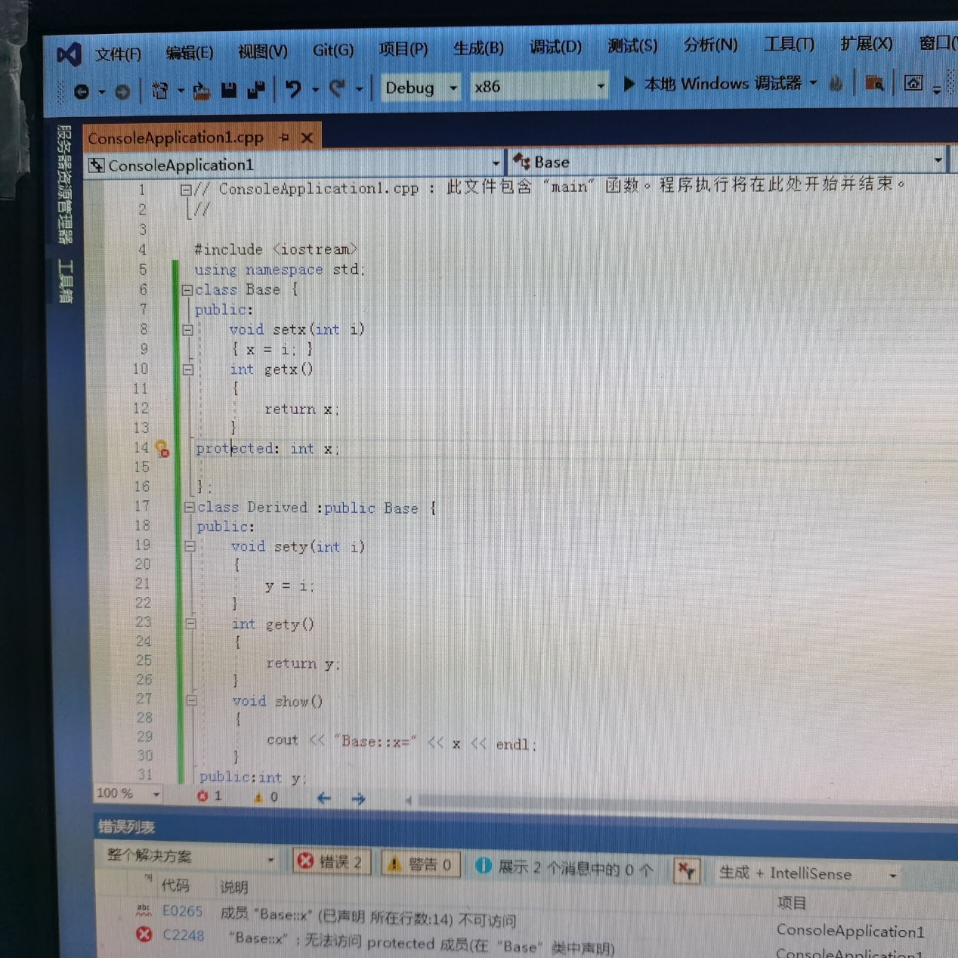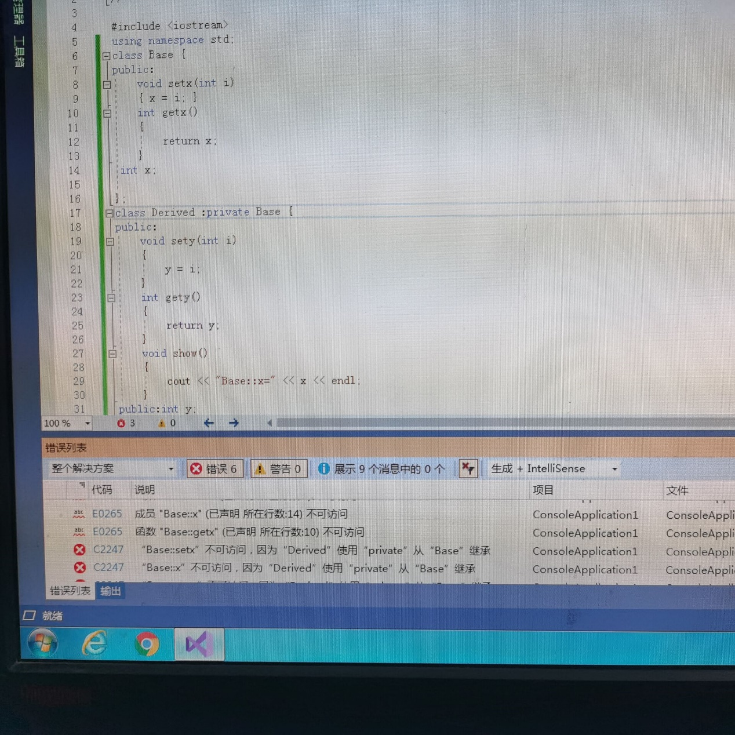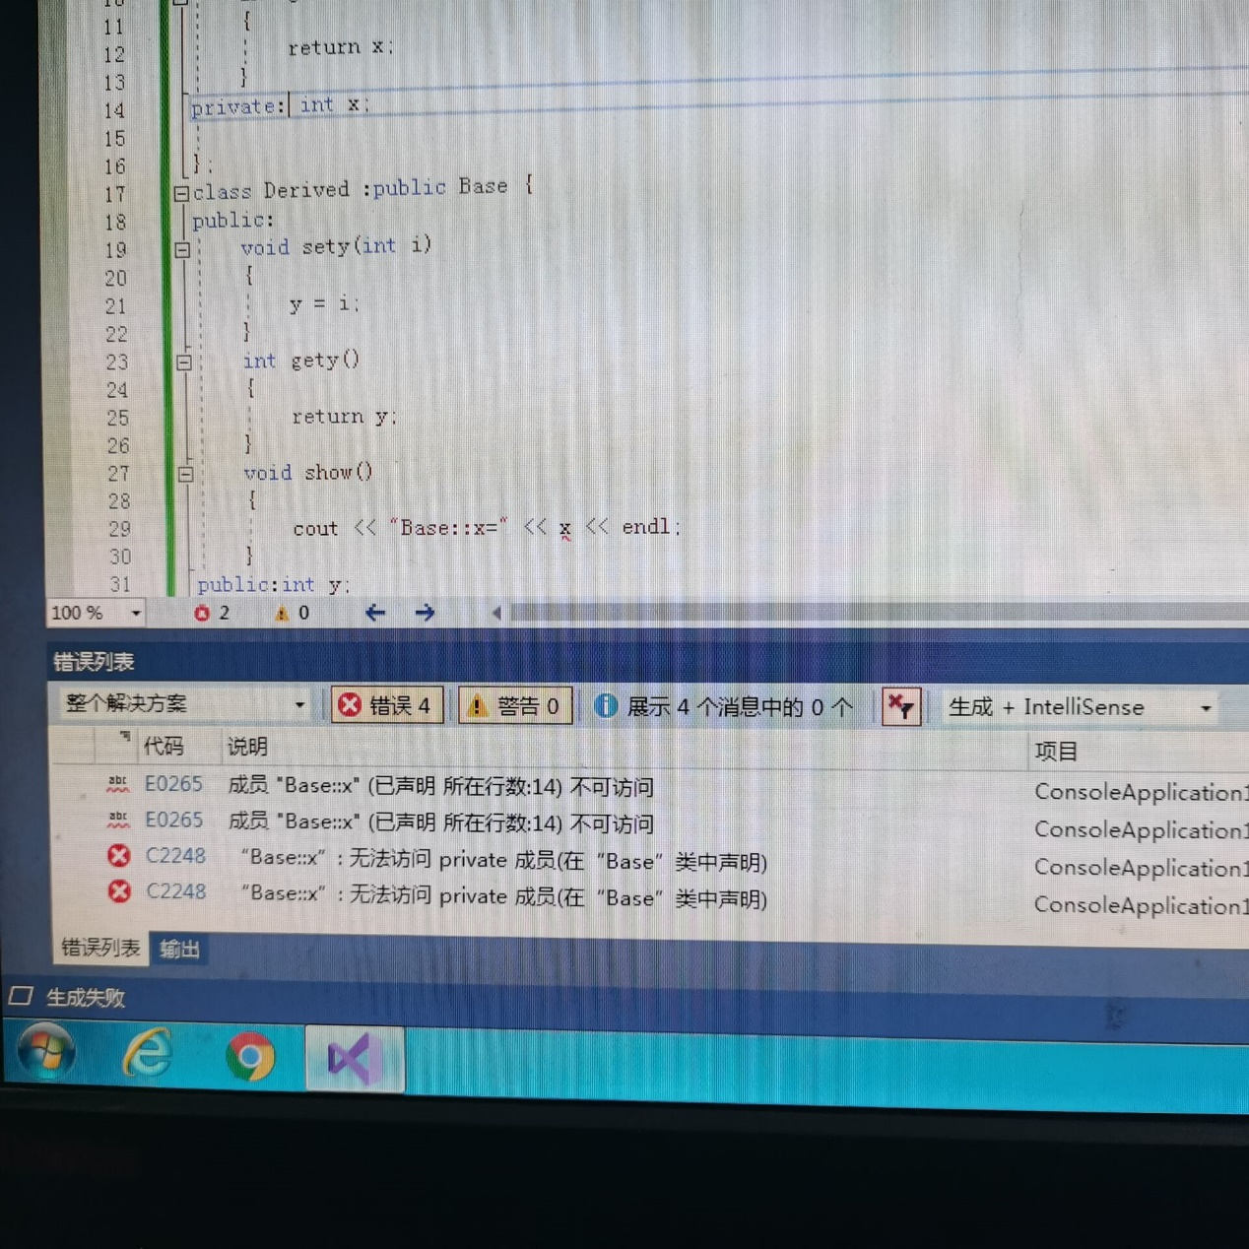感悟心得:

这次上机试验中出现了很多错误，我没想到会有这么多错误，明白了做程序一定不能马虎，一点小差错就会有大错误。

Copyright ©2021-2099 ZijianCheng. All rights reserved.